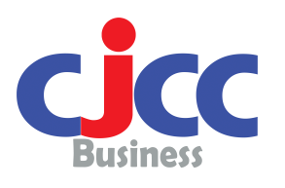
Cambodia-Japan Cooperation Center (CJCC)
Human Resource Development Hub

Registration Form
Regional Business Plan Contest
Please complete in full.  Failure to provide all the necessary information may delay your registration and affect your eligibility. |  |  |  |  |  |  | CJCC-BTD Office Use Only  Date Received: ...............................................
Personal Details
Gender: |  | □ Male □ Female |  |  |  | Address: □Personal □Company  …………………………………………………………………………………  …………………………………………………………………………………  …………………………………………………………………………………
Name in English:
Name in Native Language:
Date of Birth:
(dd/mm/yy)
Email: |  |  |  |  |  | Mobile Phone:
Name of Company:  Department/Division/Section: |  |  |  |  |  | Type of business industry/line:
Your Position and Job Responsibility:

Your Business Plan:

How many members are there in your business team? Their Names? Contact address?

Please write your purpose / reason to attend the contest:

I hereby apply for the Regional Business Plan Contest provided by CJCC and JICA.

Date: ……………………
Name & Signature

